 | TEMASEK JUNIOR COLLEGE  2026 JC2 PRELIMINARY EXAMINATION  Higher 2 | 

GEOGRAPHY | 9173/02
Paper 2  INSERT | 15 September 2026
 | 3 hours

READ THESE INSTRUCTIONS FIRST

This Insert contains all the Resources referred to in the questions.

This document consists of 9 printed pages and 3 blank pages.
Resource 1 for Question 1

Location of transects and sampling sites

Area 1: Clifton South
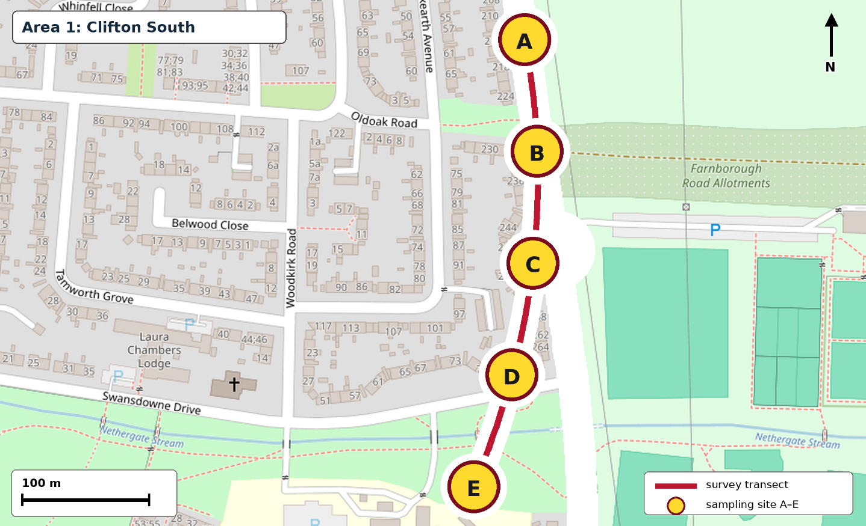
Area 2: The Park Estate
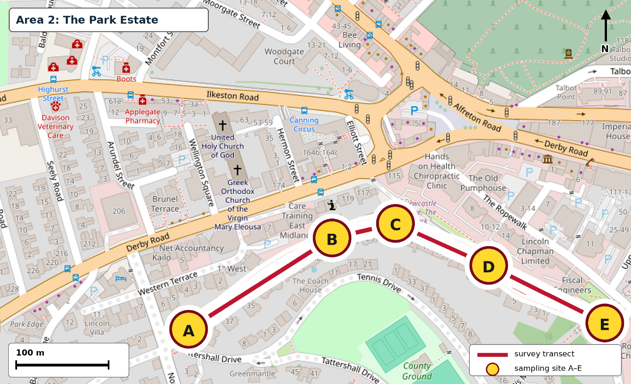

Resource 2 for Question 1

The two study areas

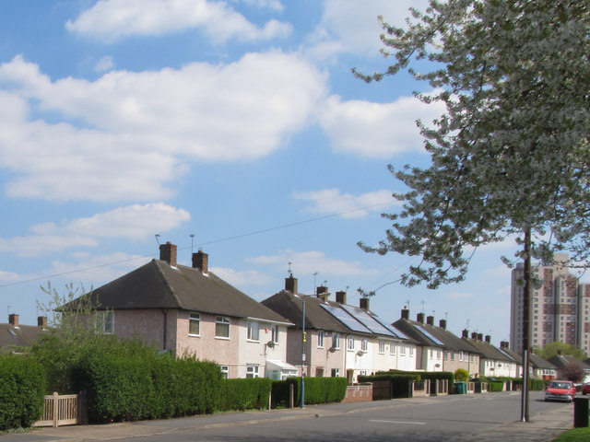
Photograph 2A: Clifton South
Solar panels on houses in Clifton South

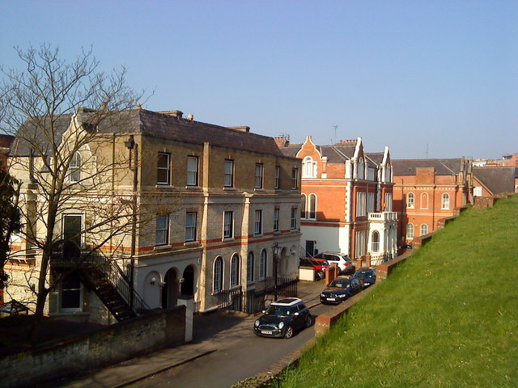
Photograph 2B: The Park Estate
Newcastle Drive in The Park Estate

Resource 3 for Question 1
Audit of visible climate-change mitigation measures*
Area / site | Residential buildings observed | Buildings with visible solar panels | Buildings with visible external insulation | Bicycle-parking spaces | EV charging points | Public recycling facilities | LED streetlights
Clifton South A | 18 | 8 | 6 | 4 | 2 | 1 | 4
Clifton South B | 21 | 11 | 9 | 2 | 1 | 2 | 5
Clifton South C | 16 | 7 | 8 | 6 | 2 | 1 | 4
Clifton South D | 24 | 12 | 11 | 3 | 3 | 2 | 6
Clifton South E | 19 | 9 | 7 | 5 | 1 | 1 | 5
The Park Estate A | 15 | 1 | 0 | 8 | 3 | 2 | 4
The Park Estate B | 28 | 2 | 1 | 6 | 5 | 1 | 5
The Park Estate C | 11 | 0 | 0 | 10 | 4 | 2 | 4
The Park Estate D | 22 | 1 | 1 | 12 | 6 | 1 | 5
The Park Estate E | 14 | 1 | 0 | 7 | 3 | 2 | 4

*Audit instructions given to students: Count each visible measure once. Record only measures that can be seen from the public pavement.

Resource 4 for Question 1

Survey Questionnaire on residents’ attitudes
towards climate change and their responses

The survey is anonymous. Please tick one response for each item unless instructed otherwise.
Responses will be used only for this geographical investigation.
A RESPONDENT PROFILE
Study area | ☐ Clifton South ☐ The Park Estate |  | Age group |  |  | ☐ 18–29 ☐ 30–44 ☐ 45–59 ☐ 60+
Length of residence | ☐ <1 year ☐ 1–5 years ☐ 6–10 years ☐ >10 years |  | Housing tenure |  |  | ☐ Owner ☐ Private renter ☐ Council/social renter ☐ Other
B ATTITUDES TOWARDS CLIMATE CHANGE

Please indicate how far you agree with each statement. |  |  |  |  | Strongly  disagree |  |  | Disagree | Neither agree  nor disagree |  | Agree |  | Strongly  agree
3. Climate change is a serious problem, so responsible residents should take action.
4. Actions taken by my household can help reduce carbon emissions.
5. The council provides enough information and facilities to help residents take climate action.
C FREQUENCY OF CLIMATE-CHANGE RESPONSES

How often do you undertake each action below? |  |  |  | Always |  |  | Often |  |  | Sometimes |  | Rarely |  | Never
6. Separate recyclable household waste correctly.
7. Use public transport instead of travelling by car.
8. Walk or cycle for local journeys.
9. Reduce electricity and heating use at home.
D REASONS, BARRIERS AND OVERALL RESPONSE

10. What are the two main reasons for taking climate-friendly action?  Tick no more than TWO. |  | ☐ Concern about climate change  ☐ Saving household costs  ☐ Convenience  ☐ Council support or incentives  ☐ Influence of family or neighbours  ☐ Other: __________
11. What most limits your ability to take further action?  Tick ONE. |  | ☐ Cost ☐ Inconvenience ☐ Lack of information  ☐ Lack of suitable facilities ☐ Housing restrictions  ☐ I do not think further action is necessary
12. Overall, how effective do you think your household’s actions are at reducing climate change? |  | ☐ Very ineffective ☐ Ineffective ☐ Neither  ☐ Effective ☐ Very effective
13. Please explain one change that would help your household respond more effectively to climate change.

Resource 5A for Question 1
Selected results of residents’ attitudes to climate-change mitigation
in Clifton South and The Park Estate.

A score of 1 represents “strongly disagree” and 5 represents “strongly agree”.
Attitude statement | Clifton South: mean score | The Park Estate: mean score
Climate change is a serious problem, so responsible residents should take action. | 4.5 | 4.4
Actions taken by my household can help reduce carbon emissions. | 4.0 | 3.8
The council provides enough information and facilities to help residents take climate action. | 3.6 | 2.8

Resource 5B for Question 1
Selected results of residents’ mitigation action
in Clifton South and The Park Estate.

Frequency of using public transport instead of travelling by car | Clifton South (%) | The Park Estate (%)
Never | 10 | 25
Rarely | 10 | 20
Sometimes | 20 | 25
Often | 35 | 20
Always | 25 | 10

Resource 6 for Question 2

King’s Cross before and after urban reimaging

Before | After
Aerial View
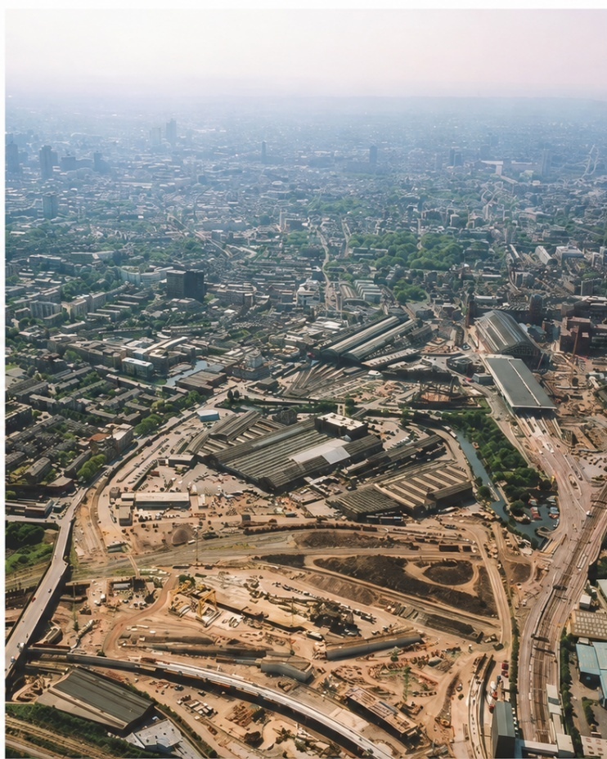 | 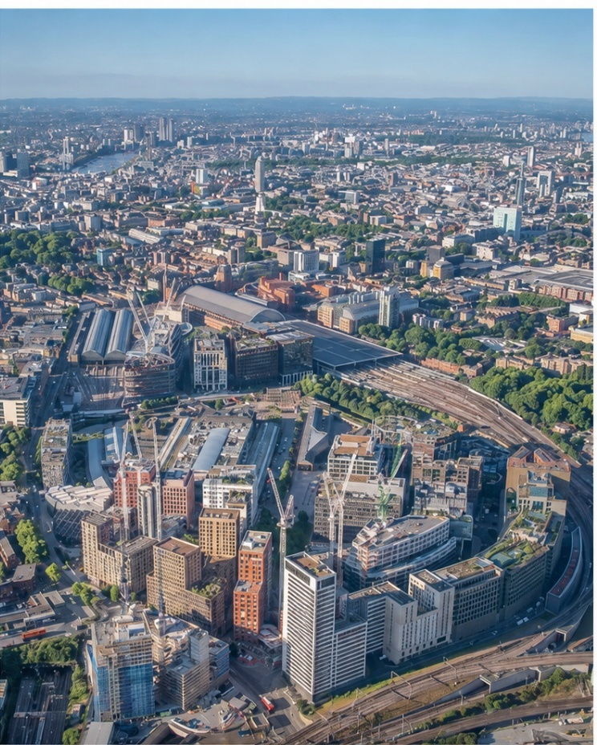
Street Level View
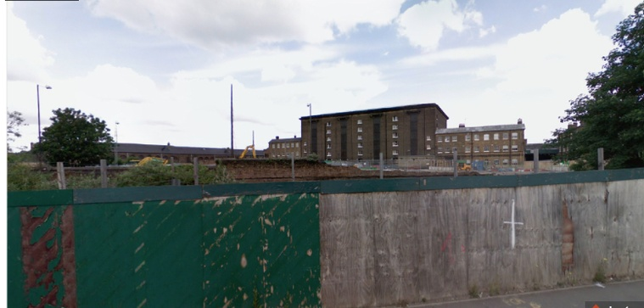 | 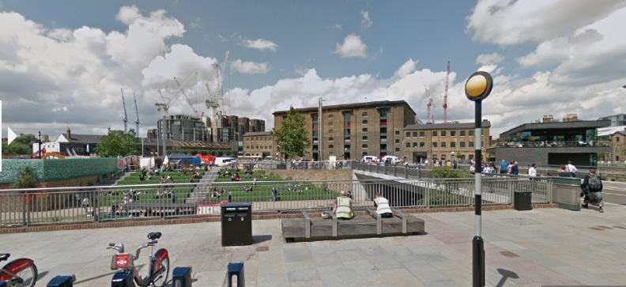

Resource 7 for Question 2

Selected SDG scores for Oslo, Norway and Athens, Greece

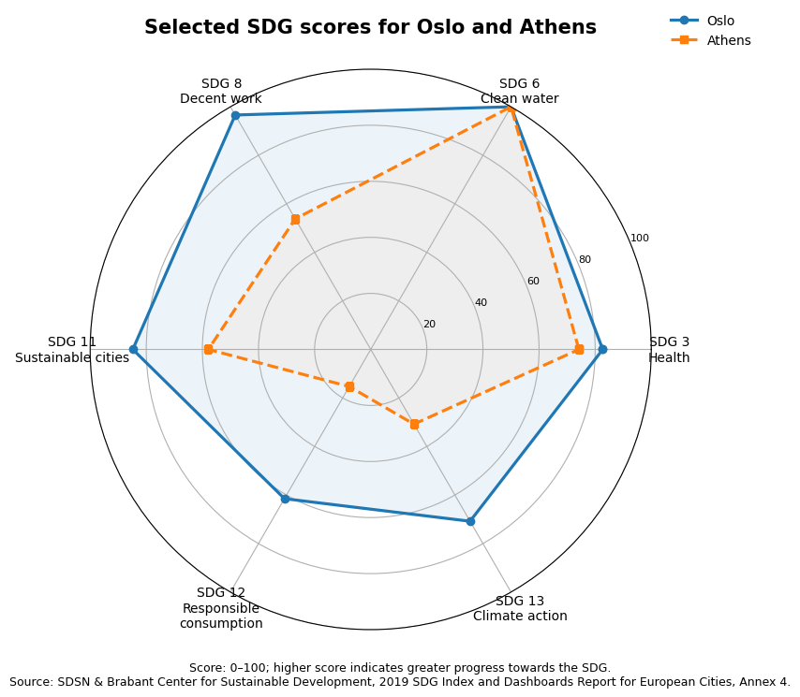

Resource 8 for Question 2

Projected global carbon dioxide emissions by sources, 2020–2100

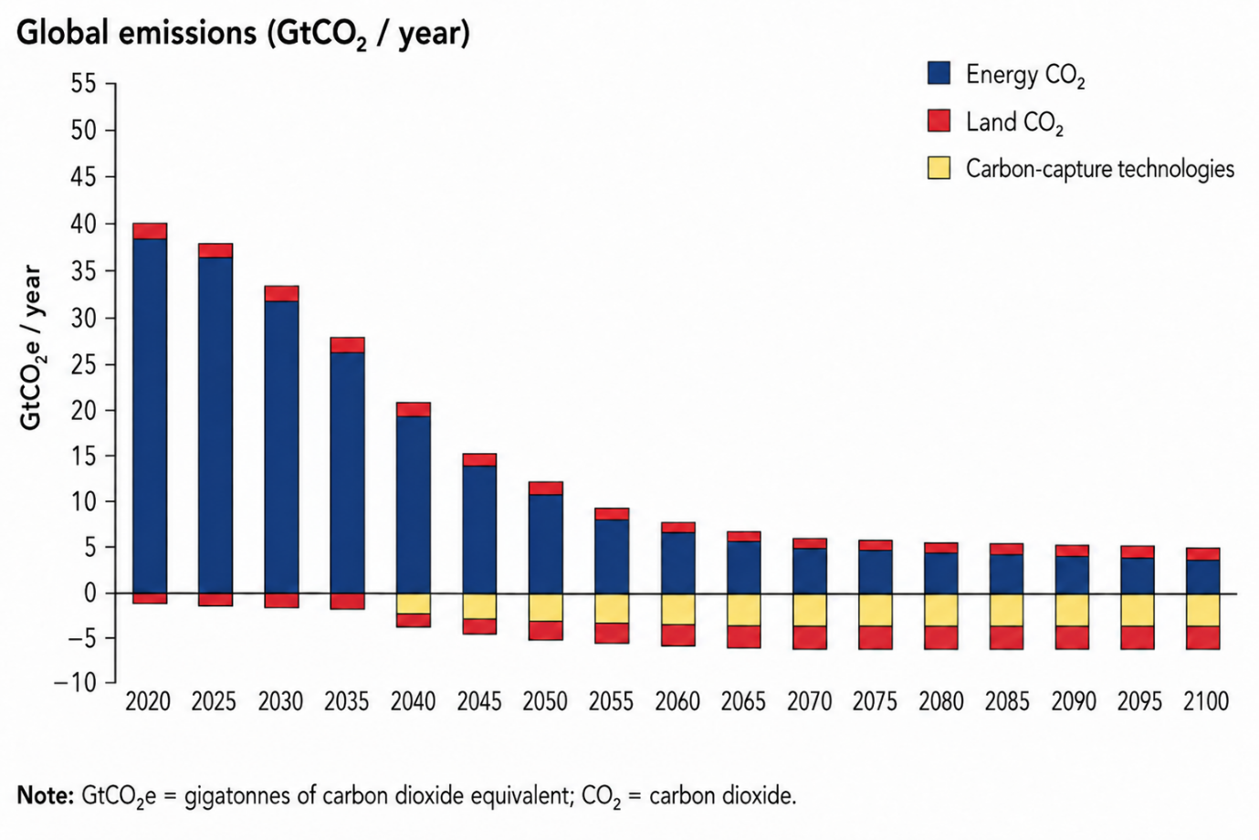

BLANK PAGE

BLANK PAGE

BLANK PAGE

